**Computer Networks Assignment**

**Objective:**

* To familiarize students with Cisco Packet Tracer.
* To set up a peer-to-peer (P2P) communication network.
* To study different types of network cables and their color codes.
* To document the observations and save the configuration file in a GitHub repository.

**Requirements:**

* Cisco Packet Tracer software.
* A GitHub account and a repository for lab assignments.
* Access to Google Classroom for submission.

**Instructions:**

Part 1: Introduction to Packet Tracer

* Ensure you have Cisco Packet Tracer installed on your computer. If not, download it from the Cisco Networking Academy website.
* Open Packet Tracer and explore the user interface. Familiarize yourself with different tools and components available in the software.

Part 2: Peer-to-Peer Communication Setup

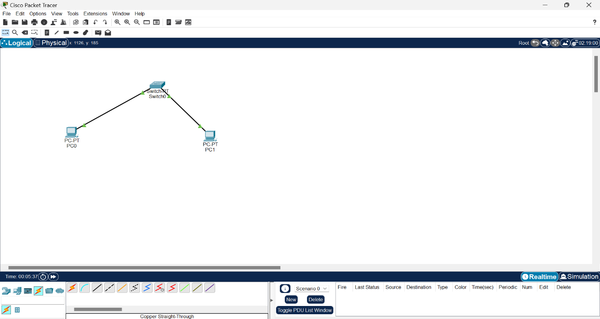

* Open Packet Tracer and create a new network.
* Add two PCs to the workspace.
* Use a copper straight-through cable to connect the FastEthernet0 port of PC0 to the FastEthernet0 port of PC1.
* Assign IP addresses to both PCs:
* PC0: IP address: 192.168.1.1, Subnet Mask: 255.255.255.0
* PC1: IP address: 192.168.1.2, Subnet Mask: 255.255.255.0
* Open the command prompt on PC0 and ping PC1 using the command ping 192.168.1.2.

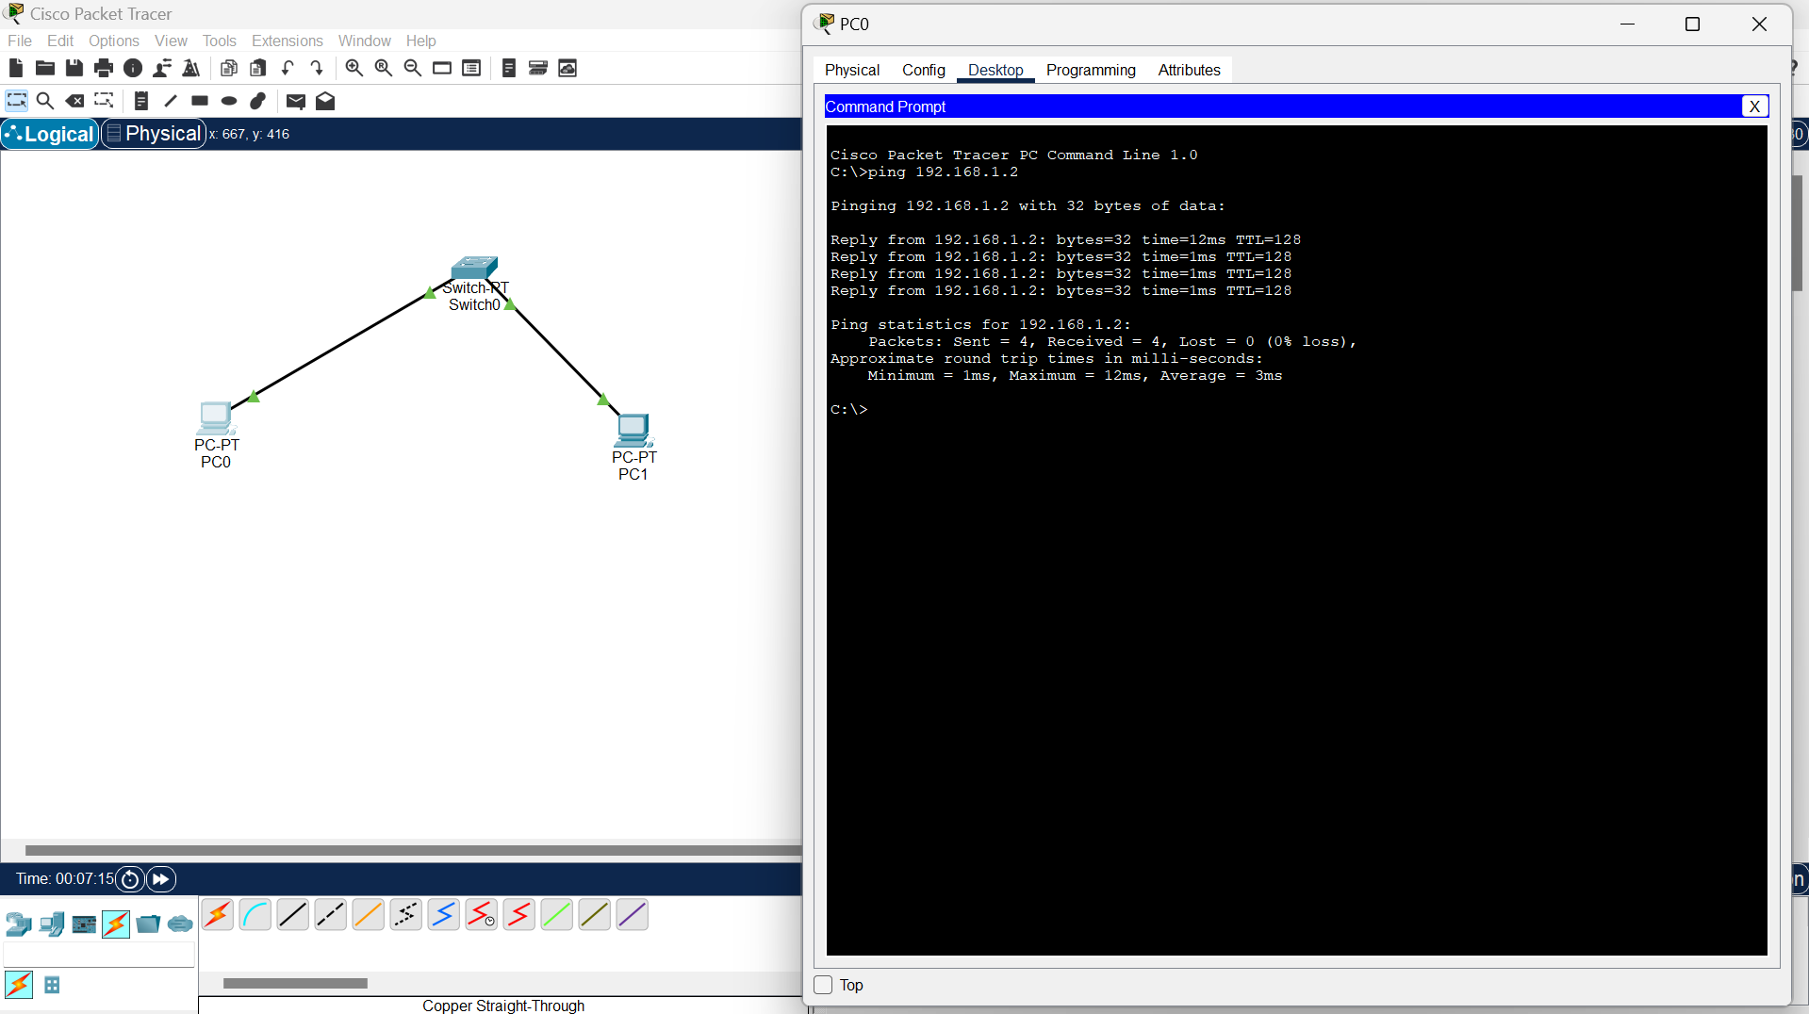

Fig2.2 Screenshot of the successful ping results

Part 3: Study of Network Cables and Color Codes

Console:-

A console cable is used to connect a computer terminal to a network device (such as a router, switch, or firewall) for configuration and management. It allows direct access to the device's command-line interface (CLI) for tasks like setup, troubleshooting, and configuration changes. The most common type is an RJ45-to-DB9 serial cable, often used with a terminal emulation program (like PuTTY) on the computer to establish the connection. This is crucial for network administrators to manage and configure network devices, especially when remote access isn't available.

Copper Straight-Through :-

A copper straight-through cable is a type of Ethernet cable used to connect different devices within a network. It uses copper conductors to transmit data. The most common use cases include:

1. Connecting Computers to Network Switches/Hubs: Allows multiple devices to communicate within a network.

2. Connecting Routers to Switches: Facilitates the routing of data between different network segments.

Each wire inside the cable is paired with its corresponding wire on both ends (e.g., pin 1 to pin 1, pin 2 to pin 2), following the T568A or T568B wiring standards. This is in contrast to a crossover cable, which connects corresponding transmit and receive pairs.

Copper Cross-Over:-

A copper crossover cable is a type of Ethernet cable used to directly connect two similar network devices, such as two computers, two switches, or two routers, without the need for a switch or hub. It allows the devices to communicate with each other by crossing the transmit and receive signal pairs, which means the transmit signal on one end goes to the receive signal on the other end, and vice versa.

Key points about crossover cables:

1. Wiring: The internal wiring crosses the transmit and receive pairs. This typically follows the T568A standard on one end and the T568B standard on the other end.

2. Use Cases:

- Direct Device Connections: Connecting two computers directly for file sharing or gaming.

- Networking Hardware: Connecting two switches or hubs directly without using an uplink port.

While crossover cables were essential for certain direct connections in older networks, many modern network devices have auto-MDI/MDIX capabilities, allowing them to automatically adjust for either straight-through or crossover cables.

Fiber:-

Fiber optic cables use light to transmit data, offering high speed and reliability over long distances. Key points:

1. Structure: Core (glass/plastic) carries light; cladding reflects light; outer protective layer.

2. Types:

- Single-Mode (SMF): Small core, long-distance, high bandwidth.

- Multi-Mode (MMF): Larger core, short-distance, lower bandwidth.

3. Uses:

- Internet backbone

- Data centers

- Telecommunications

- Local Area Networks (LANs)

Fiber optics are essential for high-speed internet and data communication.

**Phone:-**

A phone, short for telephone, is a device used for voice communication over distances. Modern phones can also support text messaging, internet browsing, and various applications. Here are key points:

1. Types:

- Landline Phones: Connected via a physical telephone line.

- Mobile Phones: Wireless, uses cellular networks.

- Smartphones: Advanced mobile phones with computing capabilities, internet access, and a wide range of applications.

2. Functions:

- Voice Calls: Primary function for direct communication.

- Text Messaging: Sending and receiving text messages (SMS).

- Internet Access: Browsing the web, email, and online services.

- Applications: Running various apps for productivity, entertainment, and social networking.

3. Technology:

- Analog Phones: Traditional phones using analog signals.

- Digital Phones: Use digital signals for clearer and more reliable communication.

- VoIP Phones: Use internet protocols to transmit voice data (e.g., Skype, WhatsApp).

Phones have evolved from simple voice communication devices to versatile tools integral to daily life and work.

**Coaxial :-**

Coaxial cables are used for transmitting data, video, and audio signals. They consist of a central conductor, an insulating layer, a metallic shield, and an outer insulating layer. Here are the key points:

1. Structure:

- Central Conductor: Usually copper, carries the signal.

- Insulating Layer: Surrounds the central conductor.

- Metallic Shield: Provides shielding from electromagnetic interference.

- Outer Insulating Layer: Protects the cable.

2. Types:

- RG-6: Common for cable television and internet.

- RG-59: Used for low-frequency applications like CCTV.

- RG-11: Used for long-distance signal transmission.

3. Uses:

- Cable TelevisionTransmitting TV signals from service providers to homes.

- Internet: Connecting modems to internet service providers.

- Satellite Communication: Connecting satellite dishes to receivers.

- CCTV Systems: Transmitting video signals from security cameras.

Coaxial cables are valued for their durability and ability to transmit high-frequency signals with low interference.

**Serial DCE :-**

A Serial Data Circuit-terminating Equipment (DCE) is a device used in serial communication to facilitate data transmission between a Data Terminal Equipment (DTE), such as a computer or terminal, and a network or communication medium. Here are the key points:

1. Function:

- Facilitates data transmission by providing clocking and signal conversion between DTE and the communication medium.

2. Examples:

- Modems

- Routers with serial interfaces

- CSU/DSUs (Channel Service Unit/Data Service Unit)

3. Connection:

- Uses serial cables (e.g., RS-232, RS-449) to connect to DTE devices.

- Common connectors include DB25 and DB9.

4. Role:

- Provides the timing (clock) for synchronization in data transmission.

- Ensures correct signal levels and formats for communication.

DCE devices are crucial in establishing and maintaining serial communication links, especially in networking and telecommunication environments.

**Serial DTE :-**

A Serial Data Terminal Equipment (DTE) is a device used in serial communication that interacts with Data Circuit-terminating Equipment (DCE) to transmit and receive data. Here are the key points.

1. Function:

- Initiates and controls data communication, typically the source or destination of data.

2. Examples:

- Computers

- Terminals

- Routers with serial interfaces (when configured as DTE)

3. Connection:

- Connects to DCE devices using serial cables (e.g., RS-232, RS-449).

- Common connectors include DB25 and DB9.

4. Role:

- Sends and receives data to/from DCE devices.

- Typically relies on DCE devices for clocking and signal conversion.

DTE devices are essential for data communication, working in tandem with DCE devices to establish a serial communication link.

**Octal :-**

Octal is a base-8 numeral system that uses digits 0 through 7. It’s often used in computing and digital systems for various purposes. Here are the key points:

1. Digits: Uses the digits 0, 1, 2, 3, 4, 5, 6, and 7.

2. Conversion:

- To Decimal: Each octal digit represents a power of 8.

- From Decimal: Decimal numbers can be converted to octal by dividing by 8 and tracking remainders.

3. Uses:

- Computer Science: Historically used in programming and digital systems due to its straightforward conversion to binary (base-2).

- File Permissions: In Unix-like systems, octal numbers represent file permissions (e.g., `chmod 755`).

4. Example:

- The octal number `175` converts to the decimal number `125` (1*64 + 7*8 + 5).

Octal simplifies the representation of binary data in a more compact form and is useful in specific computing contexts.

**IoT Custom Cable :-**

An IoT (Internet of Things) custom cable is designed specifically to meet the unique needs of IoT devices, which often require specific connectivity, power, and data transfer solutions. Here are the key points:

1. Purpose:

- Connects IoT devices to each other, to sensors, or to a central system.

- Ensures reliable data transfer, power supply, and signal integrity.

2. Types:

- Data Cables: For transmitting data between IoT devices, sensors, and controllers.

- Power Cables: For supplying power to IoT devices, especially in scenarios where power needs to be customized.

- Hybrid Cables: Combine data and power in one cable to simplify connections.

3. Custom Features:

- Length: Tailored to the specific distances required in IoT setups.

- Connectors: Customized connectors to fit unique device ports or interfaces.

- Shielding: Enhanced shielding to protect against electromagnetic interference, important for maintaining data integrity in complex environments.

- Durability: Built to withstand environmental conditions such as temperature extremes, moisture, and mechanical stress.

4. Applications:

- Smart Homes: Connecting smart devices like thermostats, lights, and security systems.

- Industrial IoT: Linking sensors, actuators, and control systems in manufacturing and process control.

- Healthcare: Integrating medical devices and monitoring equipment.

Custom cables ensure that IoT systems operate effectively by providing the necessary connectivity and protection tailored to specific applications and environments.

**USB :-**

USB (Universal Serial Bus) is a standard interface used for connecting devices to computers and other electronics. It supports data transfer, power delivery, and device communication. Here are the key points:

1. Types:

- USB-A: The most common connector, often used for peripherals like keyboards and mice.

- USB-B: Typically used for printers and other larger devices.

- USB-C: A versatile, reversible connector used for data transfer, power delivery, and video output, becoming standard in newer devices.

- Micro-USB: Common in older mobile devices and accessories.

- Mini-USB: Used in some older devices, like cameras.

2. Versions:

- USB 2.0: Supports data transfer rates up to 480 Mbps.

- USB 3.0: Offers speeds up to 5 Gbps and improved power management.

- USB 3.1/3.2: Enhances speeds up to 10-20 Gbps and introduces USB-C.

- USB4: Provides speeds up to 40 Gbps and supports Thunderbolt 3 compatibility.

3. Functions:

- Data Transfer: Moving files between devices.

- Power Delivery: Charging devices or powering peripherals.

- Device Communication: Connecting various hardware for functionality.

4. Applications:

- Computers: Connecting peripherals like keyboards, mice, and external storage.

- Mobile Devices: Charging and data transfer.

- Printers and Scanners: Direct connections for printing and scanning.

USB has become a universal standard due to its ease of use, wide compatibility, and versatility.

**Standard Color Codes for Copper Ethernet Cables**

**Straight-Through Cable**

Used for connecting different types of devices (e.g., computer to switch). The wiring follows the same standard on both ends.

- T568A Standard:

- Pin 1: White/Green

- Pin 2: Green

- Pin 3: White/Orange

- Pin 4: Blue

- Pin 5: White/Blue

- Pin 6: Orange

- Pin 7: White/Brown

- Pin 8: Brown

- T568B Standard:

- Pin 1: White/Orange

- Pin 2: Orange

- Pin 3: White/Green

- Pin 4: Blue

- Pin 5: White/Blue

- Pin 6: Green

- Pin 7: White/Brown

- Pin 8: Brown

Note: For straight-through cables, you use the same standard (T568A or T568B) on both ends.

**Crossover Cable**

Used for connecting similar types of devices directly (e.g., computer to computer). It switches the transmit and receive pairs.

- End 1 (T568A):

- Pin 1: White/Green

- Pin 2: Green

- Pin 3: White/Orange

- Pin 4: Blue

- Pin 5: White/Blue

- Pin 6: Orange

- Pin 7: White/Brown

- Pin 8: Brown

- End 2 (T568B):

- Pin 1: White/Orange

- Pin 2: Orange

- Pin 3: White/Green

- Pin 4: Blue

- Pin 5: White/Blue

- Pin 6: Green

- Pin 7: White/Brown

- Pin 8: Brown

Note: Crossover cables use T568A on one end and T568B on the other to properly align the transmit and receive pairs.

These color codes ensure consistent and proper wiring for Ethernet cables, allowing for reliable network connections.